OPERATING SYSTEM:

Linux

Default OS:- Angstrom

DRIVER CIRCUIT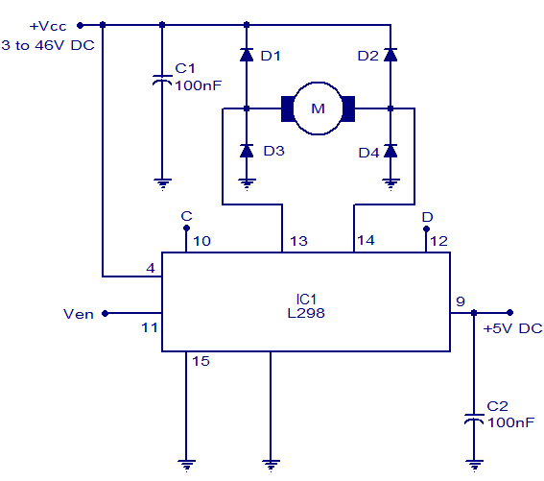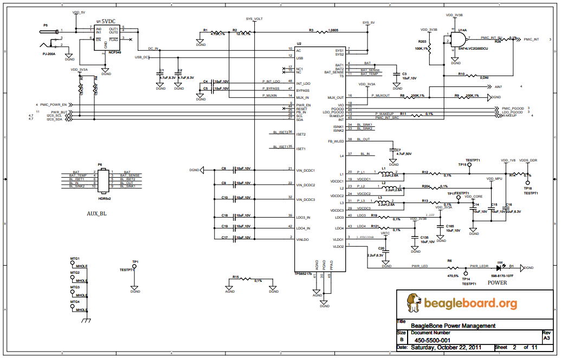

SCHEMATIC DIAGRAM